**HR VIABILITY PORTAL**

**USER GUIDE**

# PURPOSE

The purpose of this manual is to document the processes involved in using HR Viability Portal application.

# SCOPE

This manual covers all the steps involved in using HR Viability Portal application.

**REVISION HISTORY**

|  |  |  |
| --- | --- | --- |
| **REV** | **DATE** | **REMARKS** |
| First release | 05/12/2019 | Version I |

**TABLE OF CONTENT**

1.0 PURPOSE 2

2.0 SCOPE 2

3.0 Glossary of Terms 4

4.0 DESCRIPTION 4

5.0 RESPONSIBILITIES 4

6.0 user module 5

6.01 Login View 5

6.02 Initiating a new request 6

6.03 generating facility documents a new request……………………………………………………….. 7

6.04 track request status……………………………………………………………………………………..8

7.0 HRReviewer MODULE…………………………………………………………………………..……9

7.01 review Requests 9

7.02 reports 9

7.03 admin 10

8.0 hrapprover module 11

9.0 dhapprover Module 12

10.0 MDapprover Module 13

11.0 bm Module 14

12.0 internal control Module 15

13.0 audit Module 16

14.0 Useful contacts 17

# Glossary of Terms

|  |  |
| --- | --- |
| **User** | Refers to any staff with authorization to use the application. |
| **Jaiz** | Jaiz Bank PLC |
| **IT** | Information Technology |
| **UG** | User Guide |
| **URL** | Uniform Resource Locator or Web Address |
| **DH** | Divisional Head |
| **MD** | Managing Director |
| **BM** | Branch Manager |

# DESCRIPTION

   This is a HR Viability Portal platform designed for use by all staff of Jaiz Bank Plc to make requests for Facilities. It serves as a pre-approval means of filtering out various requests for facilities.

# RESPONSIBILITIES

* The functional responsibility or use of the system lies with the staff profiled for any roles as defined in the application.
* The Application Solutions Unit of IT is responsible for providing support and upgrade of the application as may be required.

# user MODULE

## Login View

* HR Viability Portal is accessible via the URL: [**http://172.13.21.160:8013/HRViabilityPortal**](http://172.13.21.160:8013/HRViabilityPortal)

Kindly note that: **You will not be able to access the portal if you are unconfirmed!**

* User Access would have to create and grant access to any staff on the application before he/she can log on to the application otherwise the user will be denied access as displayed below.

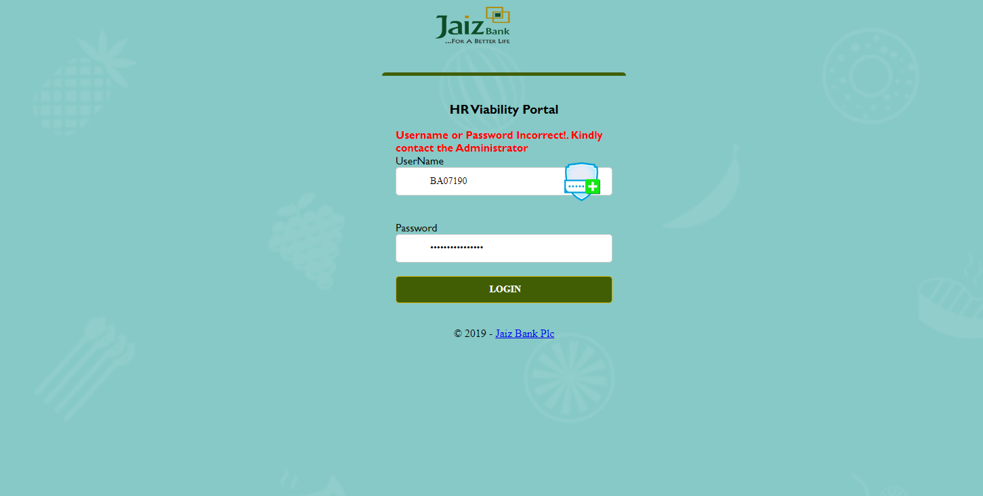

Figure 1 Login Page

## Initiating a New Request

* If the user is a valid user (has access to the application), the figure below (Figure 2) is rendered.

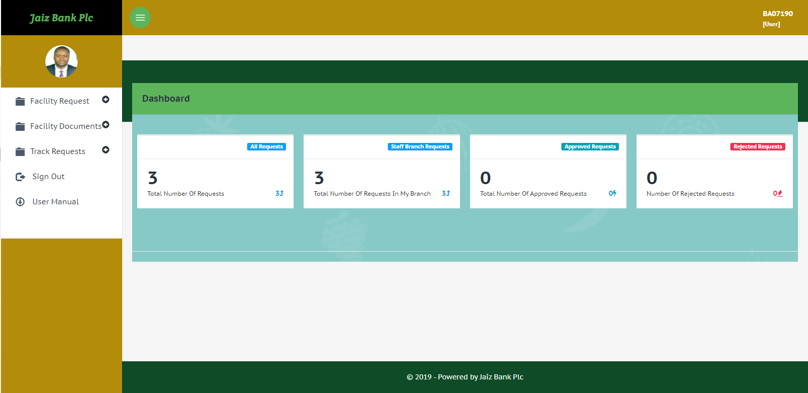

Figure 2 Landing page after login

* Form the landing page, the user can see the landing page showing the dashboard as shown below. To move ahead, kindly click on **New Request**

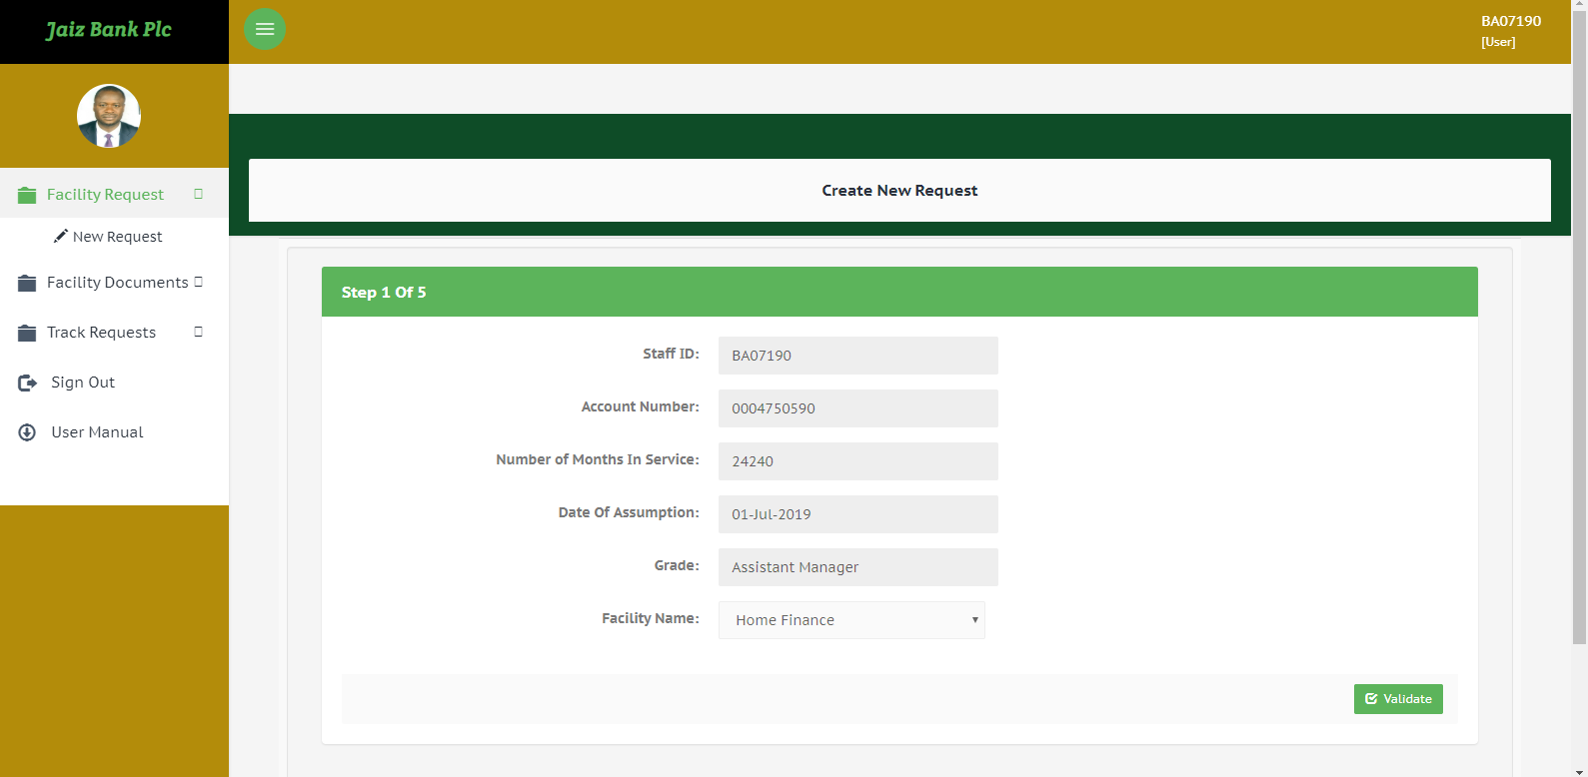

Figure3 Page after clicking New Request menu

* The User will be taken to the page as shown in figure 3. The user is expected to click on **Validate**
* Follow through on all the steps (very straight-forward) with respect to the application till completion.
  1. **Generating Facility Documents**
* User clicks on the ***‘Generate Documents’*** menu as shown below and inputs the reference number sent in the notification after completing a request application successfully.

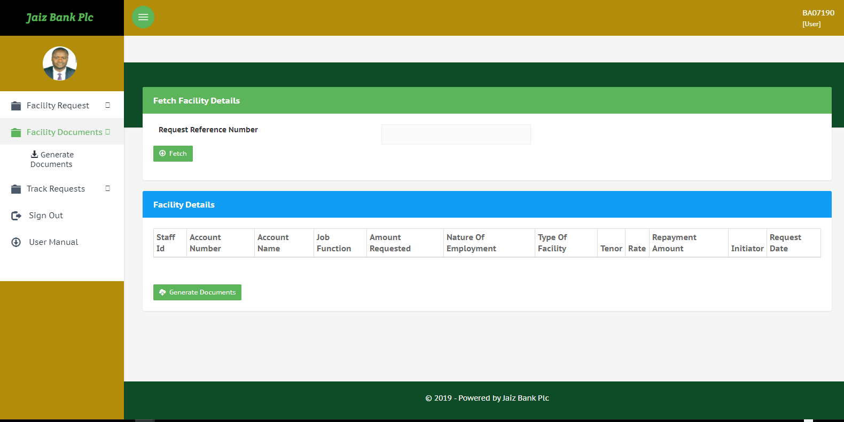

Figure4 Generate Documents Page

* Users click on the Generate Documents menu, click on the **Fetch** button after inputting the reference number in the field provided and also click on **Generate Documents button** after the details of the user’s facility is shown.

**6.04 Track Request Status**

* Users can also track the status of their request to find out where/whose table their requests I presently sitting on as shown below:

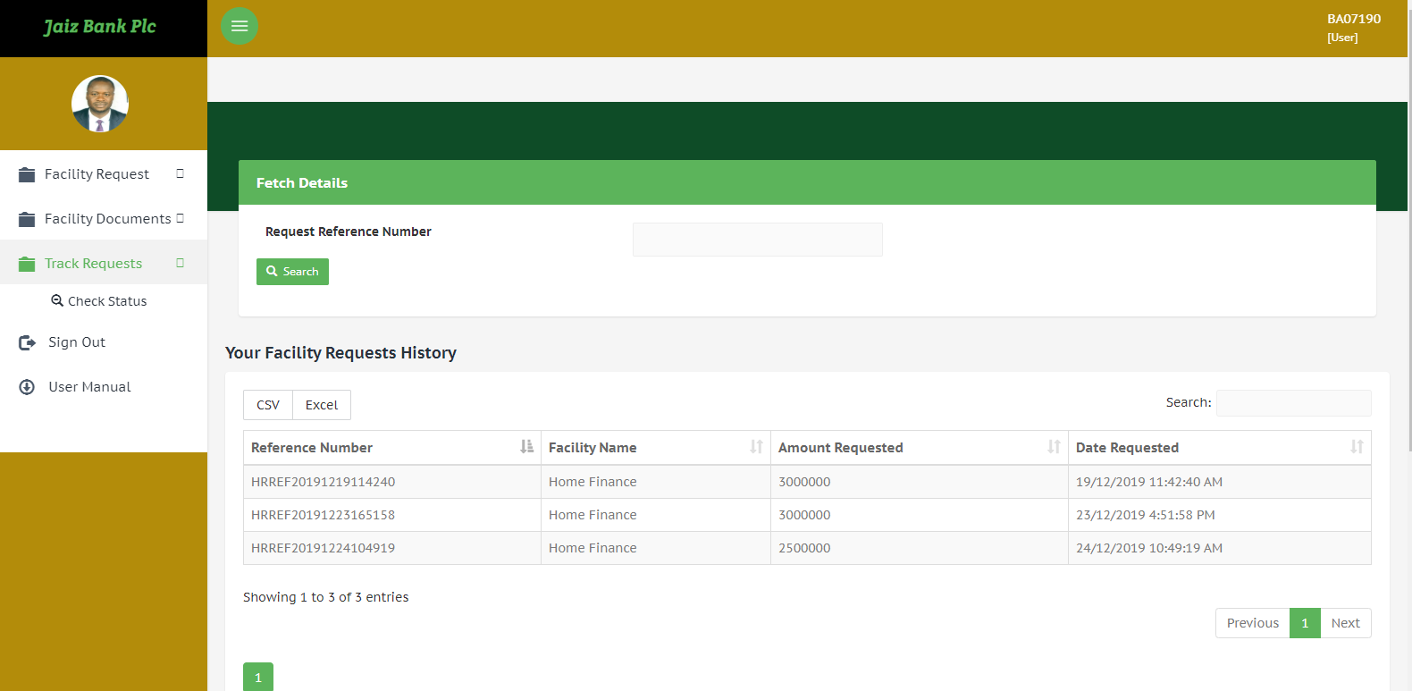

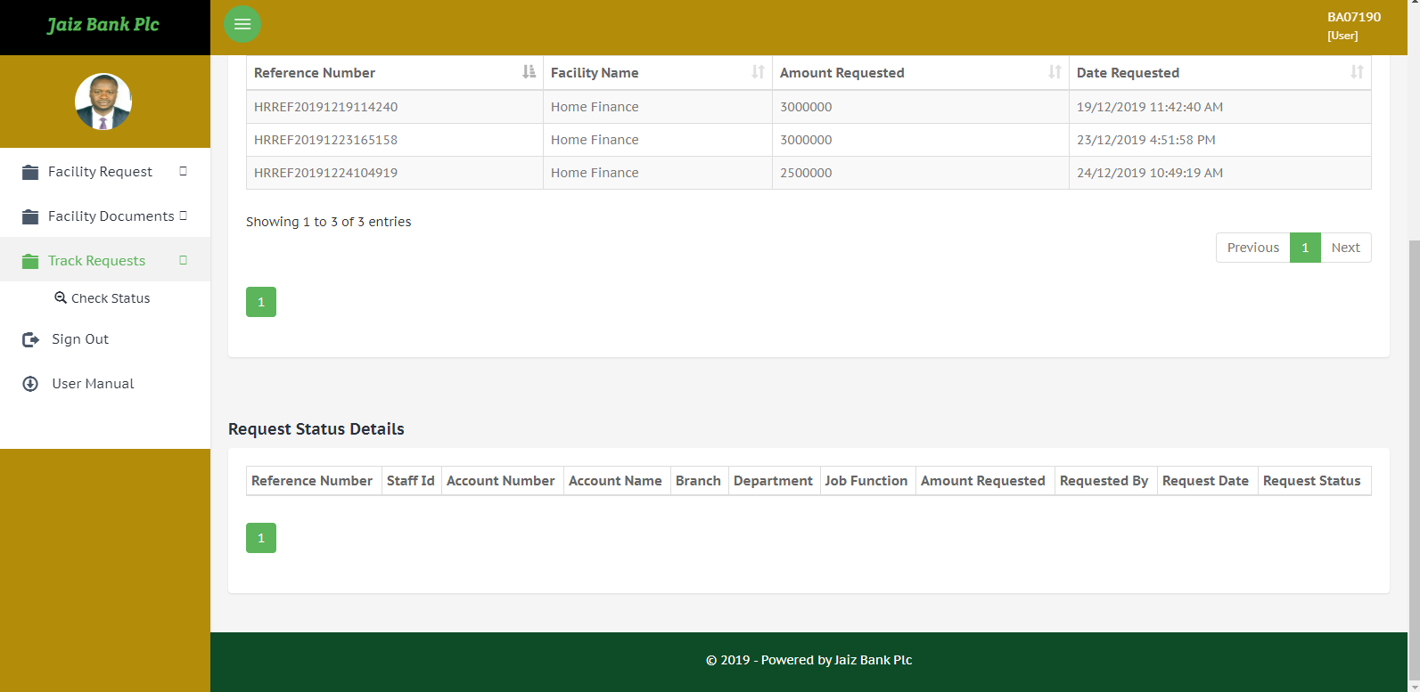

# HRREVIEWER MODULE

**7.01 Review Requests**

* HR Reviewer clicks on Review Requests menu to work various facility requests that was initiated by users as shown below:

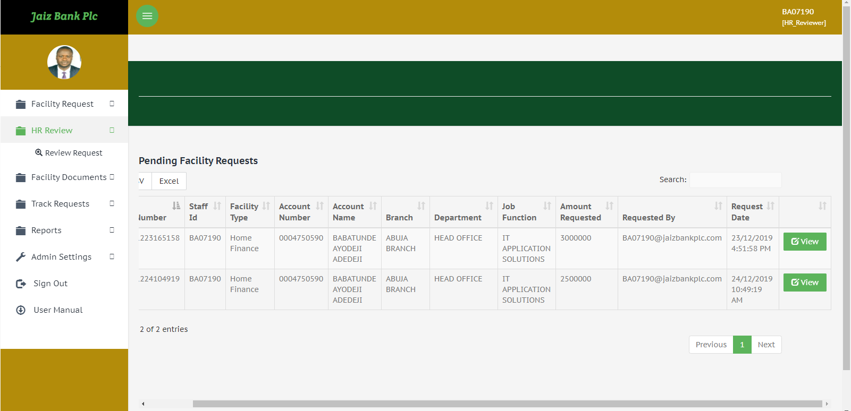

* HR Reviewer clicks on the **View** button as shown above to review the Facility Request and Approve/Reject the Facility.
* HR Reviewer can also access the following menus: New Requests, Generate Documents, Track Request Status, etc
  1. **Reports**
* HR Reviewer can also access various Reports: Approved, Rejected and Branch Reports as shown below:

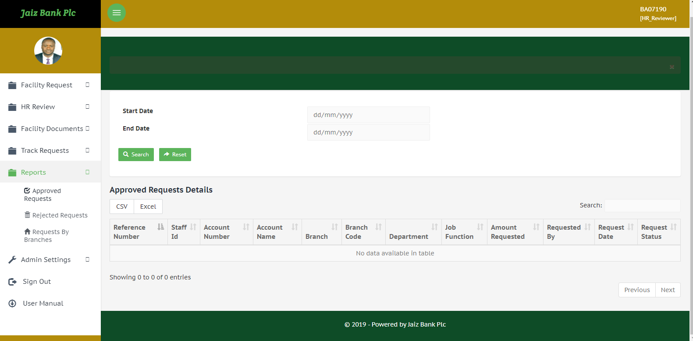

**7.03 Admin**

* HR Reviewer needs to configure some settings in the admin menu before the portal could be fully functional. Functions such as Create Facility (For new facilities), Create Facility Rules (Conditions to be met before accessing a facility), etc as shown below:

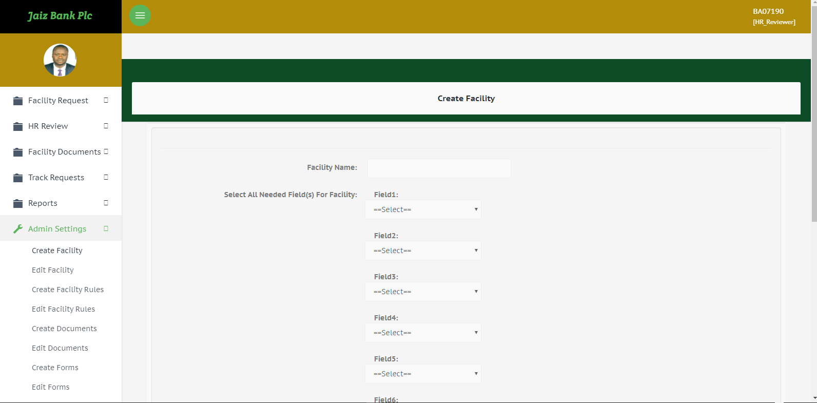

# HRapprovER MODULE

* HR Approver clicks on Approve Requests menu to work various facility requests that was initiated by users and reviewed by the HR Reviewer as shown below:

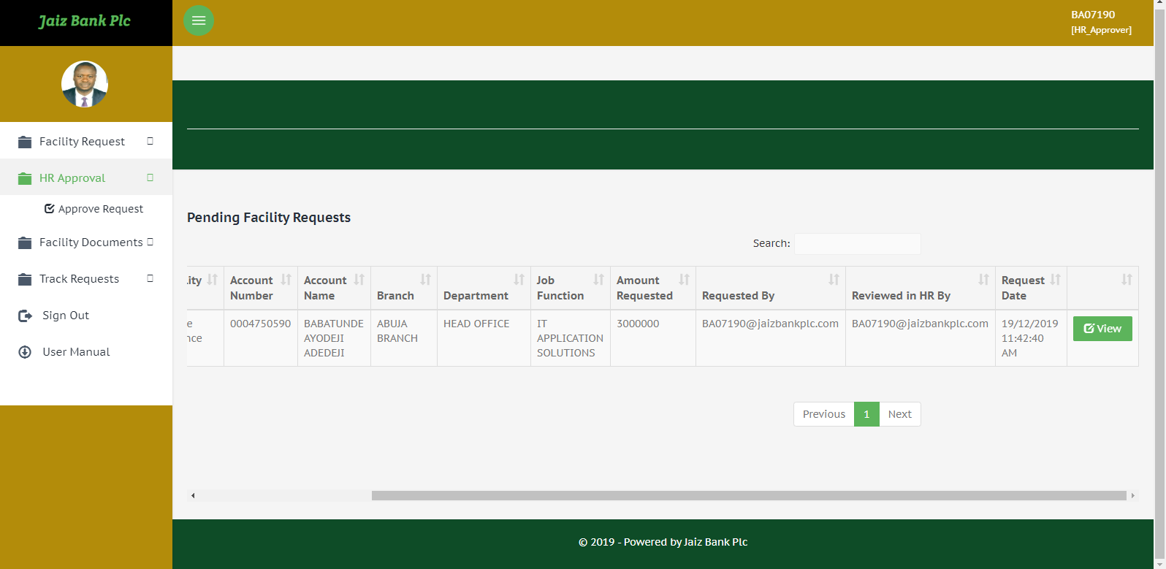

* HR Approver clicks on the **View** button as shown above to review the Facility Request and Approve/Reject the Facility.
* HR Approver can also access the following menus: New Requests, Generate Documents, Track Request Status, etc

# DHapprovER MODULE

* DH Approver (Divisional Head) reviews and approves/rejects facility requests which was approved or worked on by the Head of HR depending on the flow of the request if it flows to the DH or straight to the MD directly as shown below:

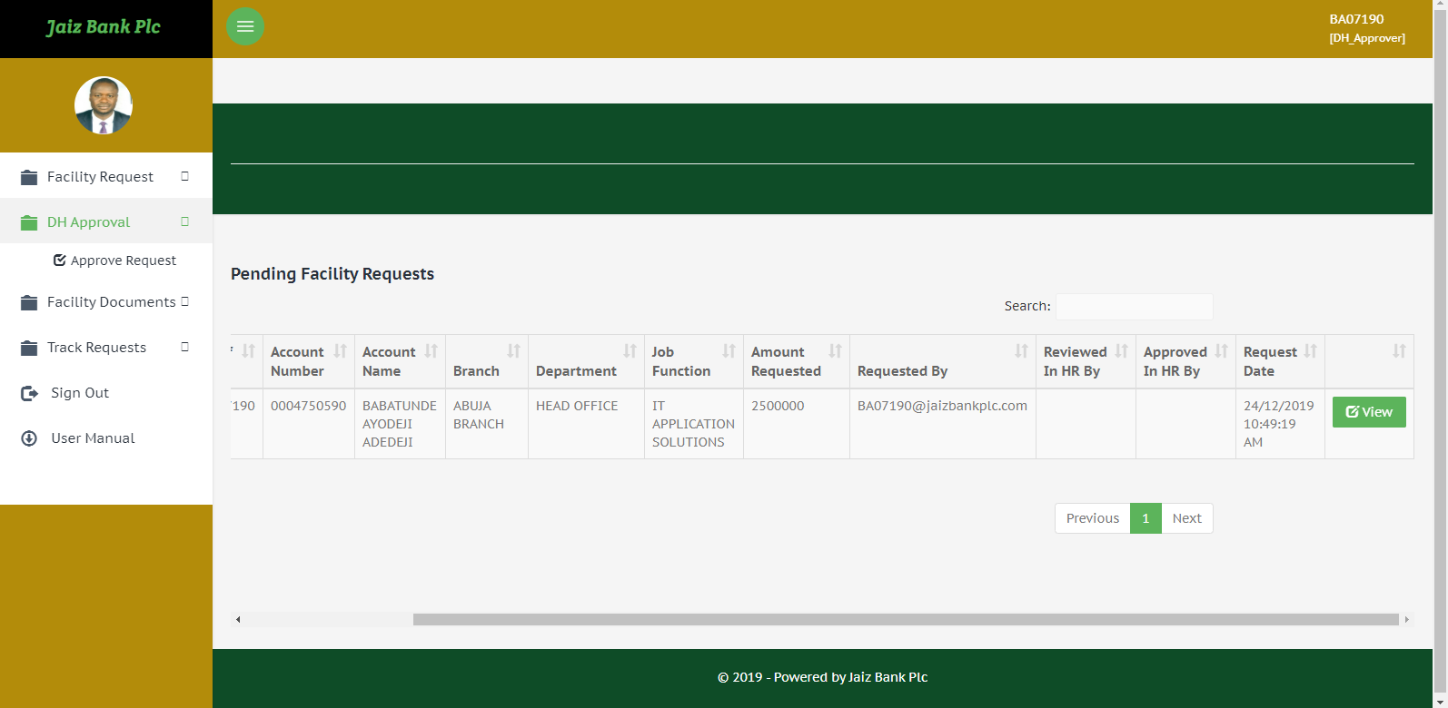

* DH Approver (Divisional Head) clicks on the **View** button as shown above to review the Facility Request and Approve/Reject the Facility.
* DH Approver (Divisional Head) can also access the following menus: New Requests, Generate Documents, Track Request Status, etc

# MDapprovER MODULE

* MD Approver (Managing Director) reviews and approves/rejects facility requests which was approved or worked on by the Head of HR/Divisional Head depending on the flow of the request if it flows to the MD or straight to the BM of the user’s branch directly as shown below:

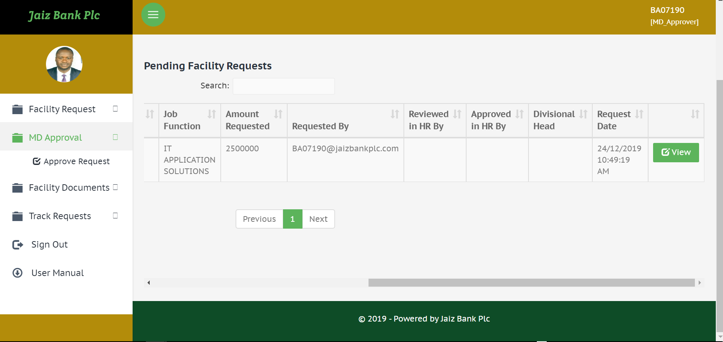

* MD Approver (Managing Director) clicks on the **View** button as shown above to review the Facility Request and Approve/Reject the Facility.
* MD Approver (Managing Director) can also access the following menus: New Requests, Generate Documents, Track Request Status, etc

# BM MODULE

* The BM (Branch Manager) is the last line of the flow of the Facility Requests. He/she only approves the Facility Requests and that ends the cycle of the application. The page is shown below:

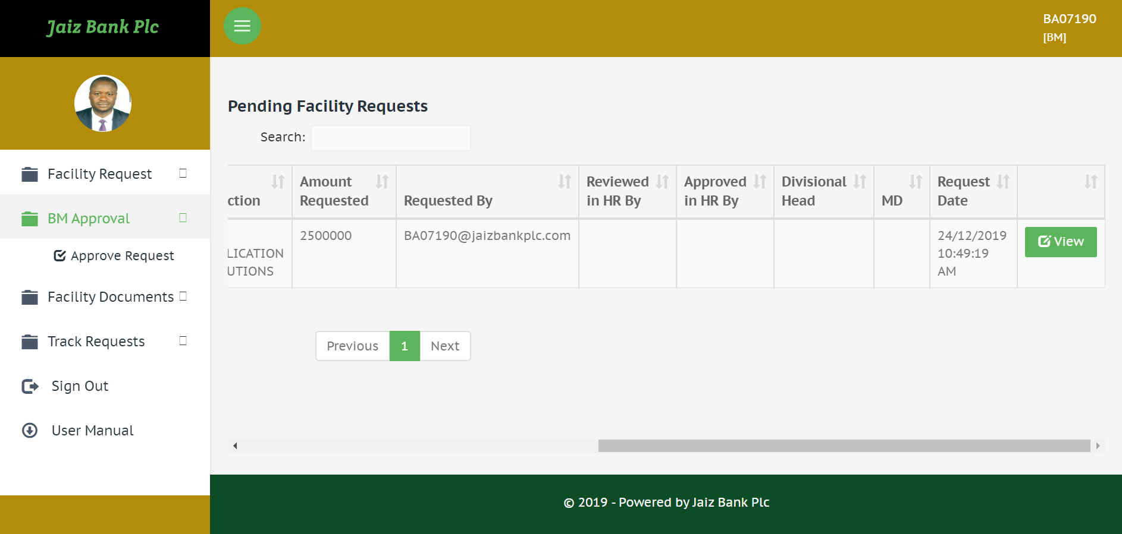

* The BM (Branch Manager) clicks on the **View** button as shown above to review the Facility Request and Approve/Reject the Facility.
* The BM (Branch Manager) can also access the following menus: New Requests, Generate Documents, Track Request Status, etc

# internal control MODULE

* The Internal Control User has access to the following menus: New Requests, Generate Facility Documents, Track Request Status, Reports. The page is shown below:

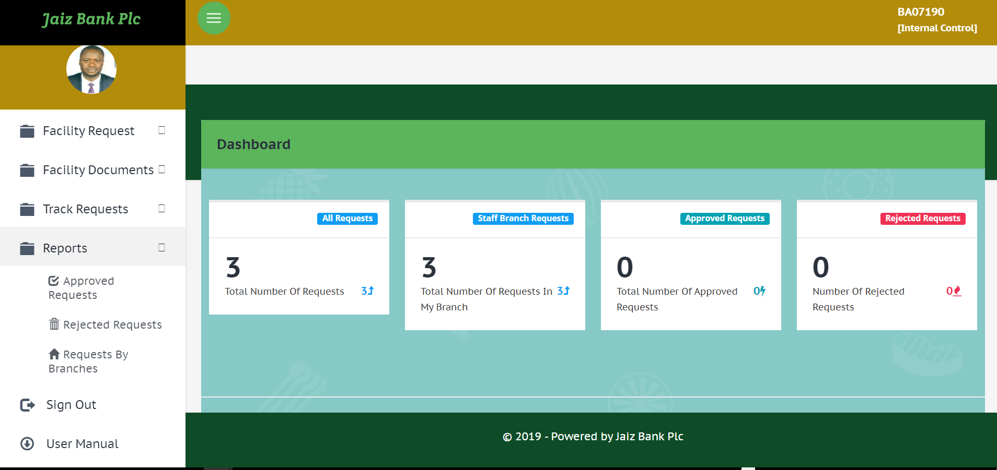

# AUDIT MODULE

* The Audit User can view all the applications logs (Audit Logs) for Audit purposes. To know who did what?, who logged in and at what particular time?, etc. The user needs to enter a date range for the logs he/she needs to check/view. The page is as shown below:

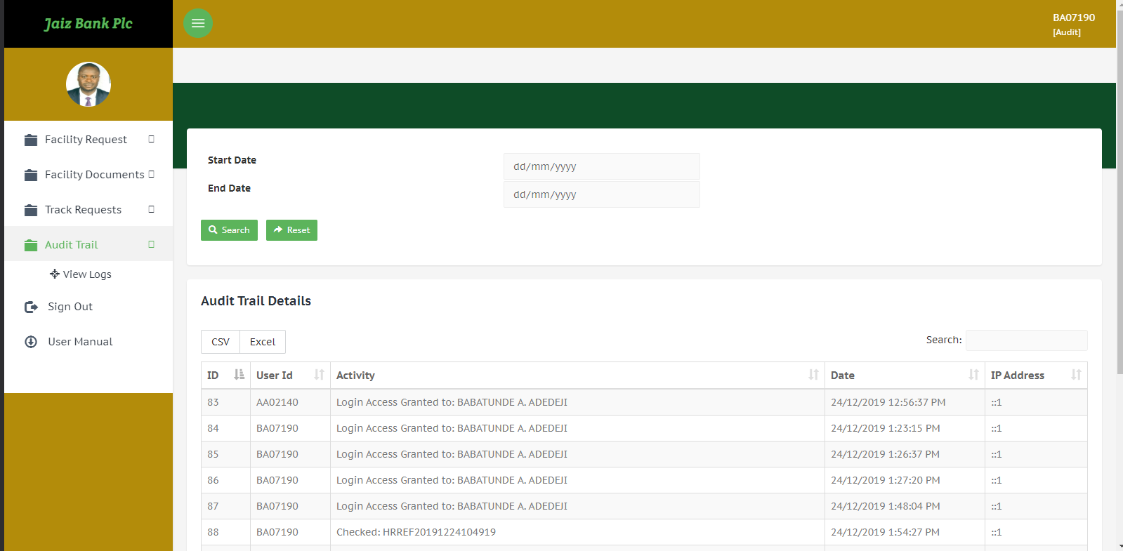

* The Audit User can also access to the following menus: New Requests, Generate Facility Documents, Track Request Status, Reports. The page is shown below:

# Useful contacts

All complaints and/or enquiries should be forwarded to IT Application Solutions team via the following means:

* Email: [appsolutions@jaizbankplc.com](mailto:appsolutions@jaizbankplc.com)
* Phone: (09 460) 5238